TRUE VS. FALSE SIGNATURES

I. INTRODUCTION

An important key to a successful asteroid search campaign is being able to identify true and false signatures for moving objects. Not all objects that appear to move in the image sets are asteroids. Citizen scientists must know the difference and only measure the asteroids (the true signatures), and not the false signatures.

For an object to be accepted as a true signature the object has three characteristics:

- Moves along a straight line
- Moves at constant speed
- Magnitude is fairly constant

A simple test for your citizen science group to use is to place the edge of a ruler along the path of the moving object to check if the motion is along a straight line. If not, then the object is a false signature and should not be measured and included in the MPC report.

II. EXAMPLES OF FALSE SIGNATURES

1. False Signature – Must not be included in the MPC report.

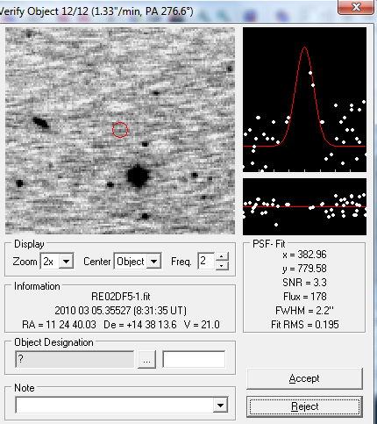
This object is rejected because the white dots are scattered away from the red lines.

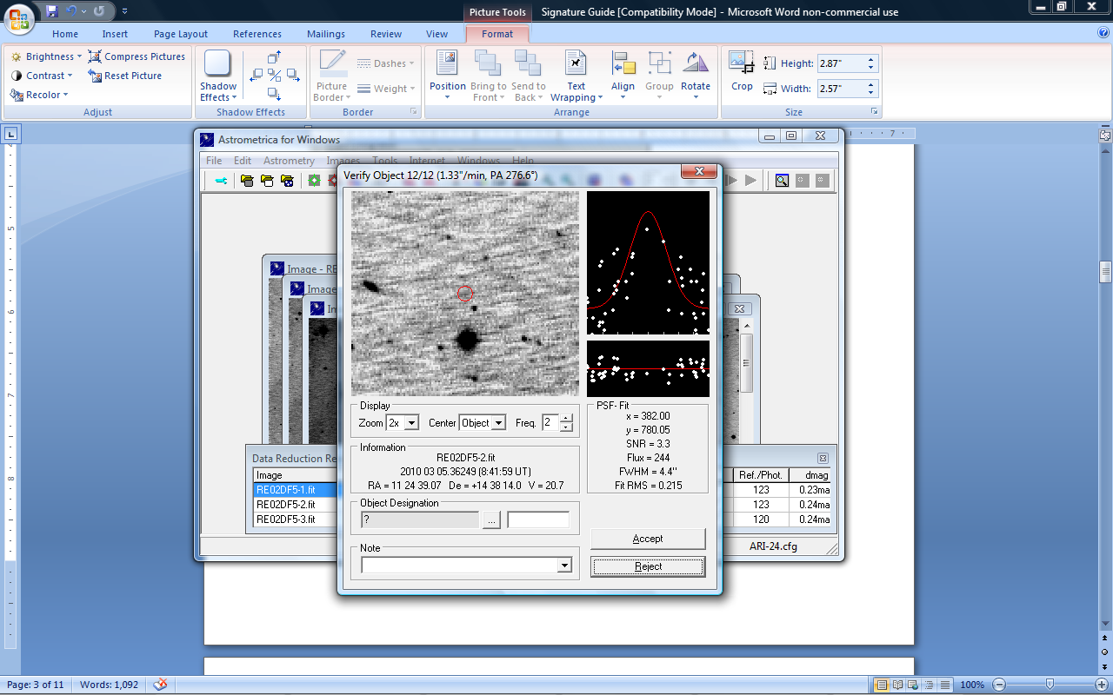

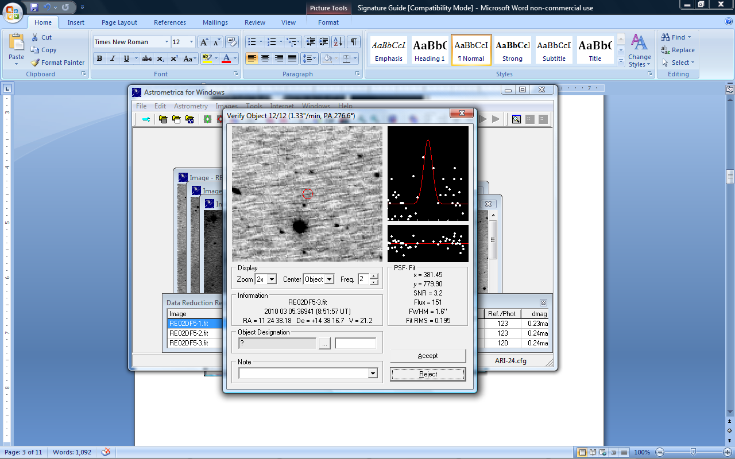

This object is also rejected because the SNR is less than 5.

This object is also rejected because the magnitude fluctuates by more than 1.

2. False Signature – Must not be included in the MPC report.

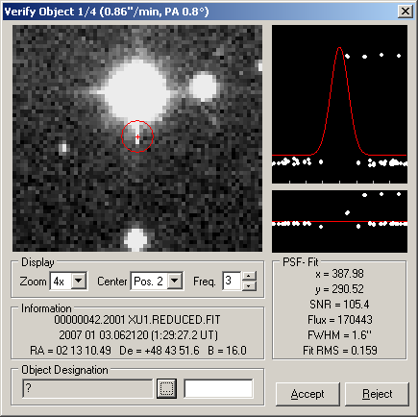
This is saturation from a bright star. Never measure and report saturated objects.

III. MANUAL SEARCH

- Select Data Reduction on the menu bar, and select OK in the box that appears. This function will find reference stars in your images.

- Select Known Object Overlay on the menu bar, then select the Blink Images button and zoom in twice to enlarge the image.

- Visually scan the blinking image for moving objects.

IV. MANUAL MEASUREMENT

- When a moving object is detected, select Stop Blinker on the menu bar.
- Begin by forwarding to Image 1, by clicking on the Forward or Back button.
- Center the object with the cross-hair and click on the object.
- Click on Object Designation and check for an object close to 0.00 in declination and right ascension, then select that object and click “OK”, then click “Accept”. If there is not an object close, then give the object a name by typing 3 initials to represent your group and a 4 number designation.

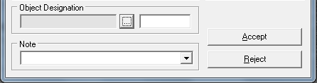

*The name must consist of 3-letters 4-numbers. For example Hardin-Simmons University might enter HSU0001 for the first discovery, HSU0002 for the second discovery, and so on. This must
be a unique name for each discovery during a 30-day campaign. No spaces are allowed in the name!

- Repeat the procedure for images 2, 3, and 4 by forwarding to Image 2 and then to Image 3, and finally to Image 4, repeating the same procedure as with Image 1.

- Continue searching the image until all asteroids have been measured.

VI. TRUE SIGNATURE EXAMPLES

The following images show examples of true signatures (asteroids). They can vary in shape, size and brightness. The asteroids will be moving in a straight line, with constant speed and its magnitude will not change greatly. The edges will be rounded and the object will be darker at the center.

